**Day 11 Assignment**

**Create and run the ansible playbook**

Created httpd.yaml ansible playbook

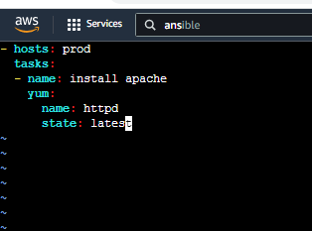

Checking the syntax



Running the playbook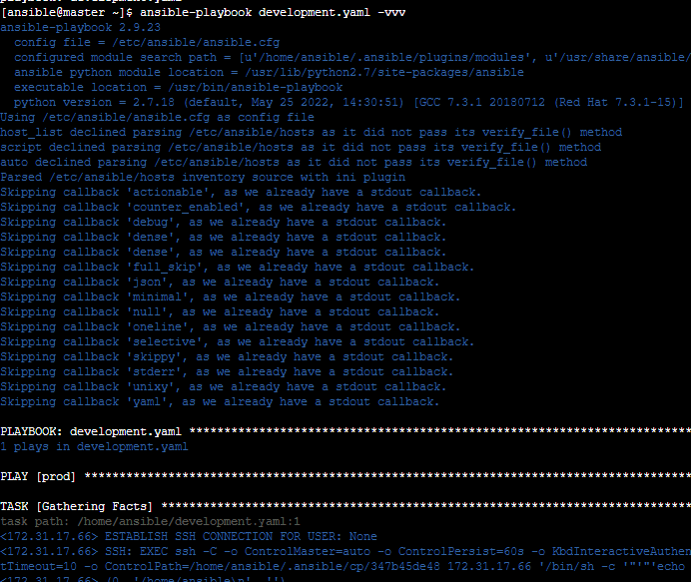

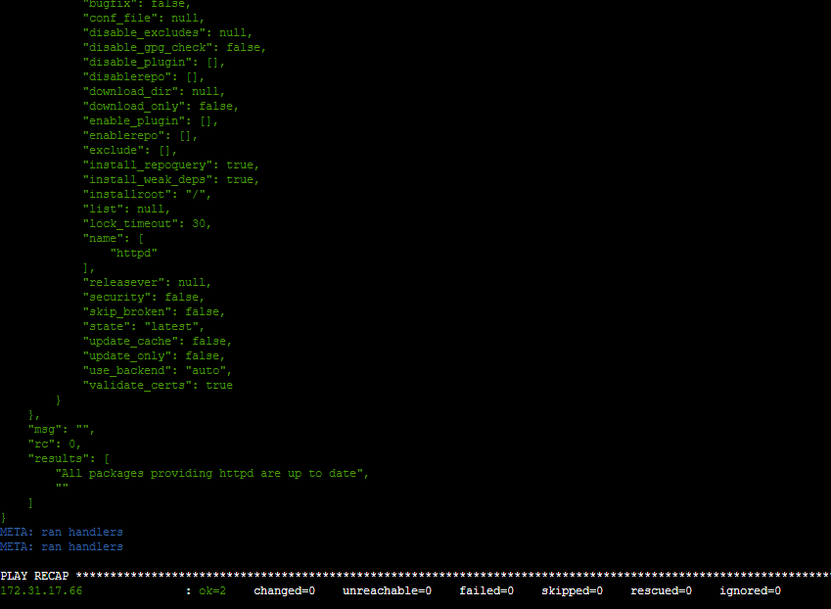

**Multiple user create in ansible_playbook**

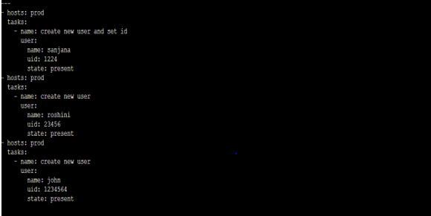

check syntax :



Playbook running:

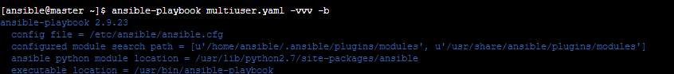

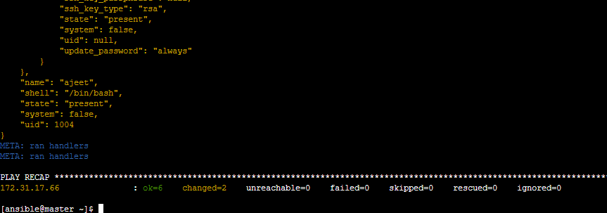

multiple user created in worker :

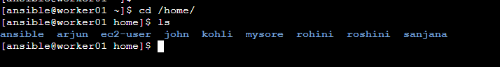

**Created copy.yaml ansible playbook**

created one activity.html filein tmp

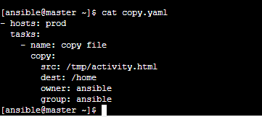

Running playbook

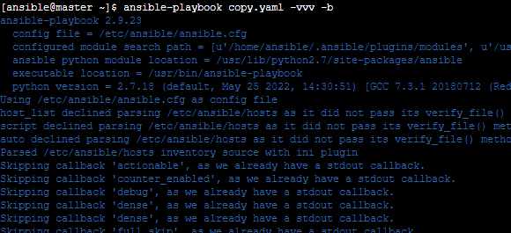

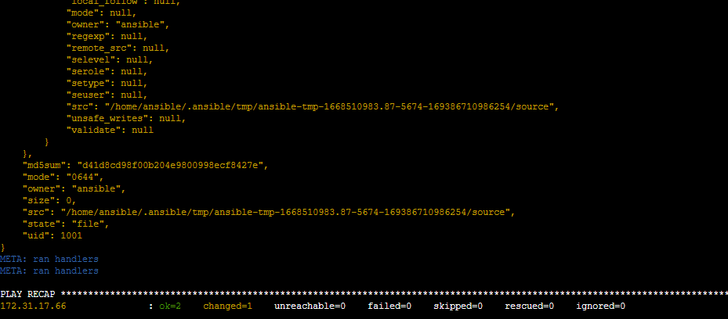

check worker node activity.html file copied to the destination

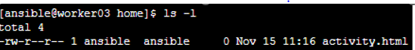

**Created user_id.yaml ansible playbook**

Set username and userid



syntax check :



Playbook running:

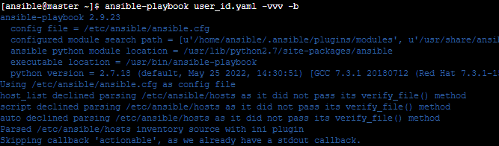

Output :

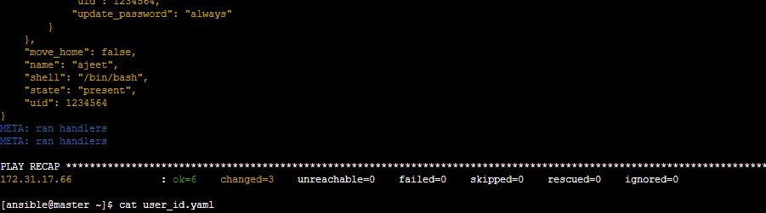

**Created tag.yaml ansible playbook**

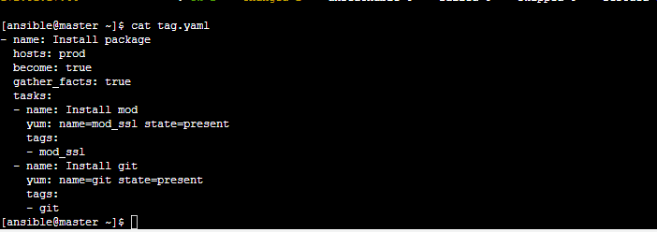



ansible-playbook tag.yaml --skip-tag git

skipped git by tag

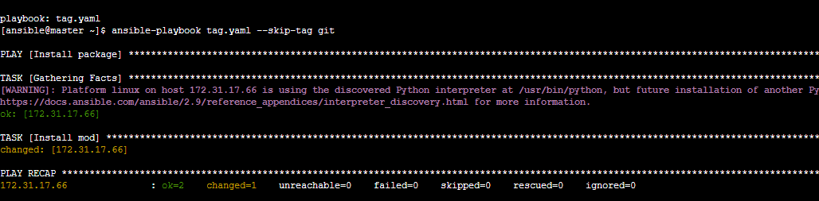

installed git by remove skip

ansible-playbook tag.yaml --tag git

